**Purpose**

To establish a standard procedure for grossing of thymectomy specimens for myasthenia gravis and thymic neoplasms.

**Background**

The thymus is an organ located in the anterior superior mediastinum that produces mature T lymphocytes. The thymus lies over the mediastinal pleura and pericardium and is bordered anteriorly by the sternum, superiorly by the lower pole of the thyroid, and inferiorly by the diaphragm. It has two lobes—right and left—made up of lobules consisting of a medulla and cortex wrapped in a fibrous capsule.

Nearly half of all mediastinal tumors occur in the anterior mediastinum and usually arise within the thymus. Thymic epithelial tumors, most of which are thymomas, are the most common thymic tumors and are classified according to their microscopic appearance into six different categories. Thymic carcinomas are the most aggressive and generally are diagnosed at an advanced stage. Thymic carcinomas do not resemble normal thymic tissue and are morphologically similar to carcinomas occurring in other organs. Subtypes include squamous cell carcinoma, basaloid carcinoma, mucoepidermoid carcinoma, lymphoepithelioma-like carcinoma, sarcomatoid carcinoma, clear cell carcinoma, adenocarcinoma, and neuroendocrine carcinoma. Thymomas are often associated with myasthenia gravis and other autoimmune diseases, while thymic carcinomas are not.

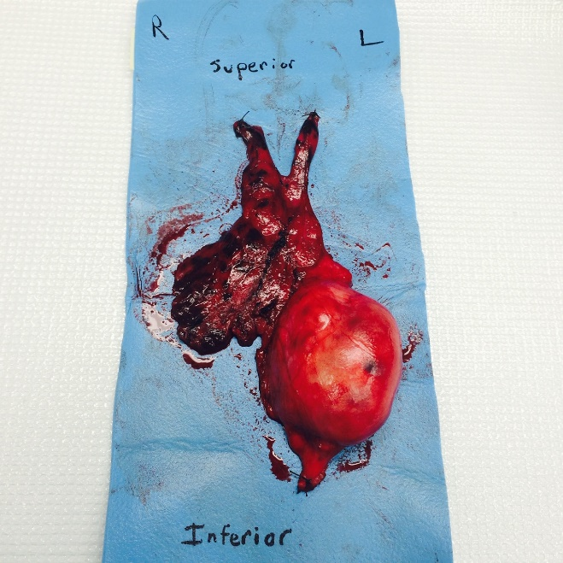Thymectomies are performed as part of a treatment regimen myasthenia gravis or thymic neoplasms. These specimens are almost always received sutured to a foam pad and are oriented by the surgeon (see *Figure 1*). If orientation is in question, or the thymus becomes detached from the foam pad, contact the surgeon for clarification. Some specimens come with attached adjacent tissue, such as pericardium, pleura, and/or lung. The posterior margin in these specimens represents a true margin, as this is where the thymus is dissected from the pericardium and mediastinal pleura to be mobilized and removed. Thymomas are encapsulated and have grey-tan, lobulated and sometimes cystic cut surfaces with intervening fibrous septa, while thymic carcinomas are usually large, firm, poorly-circumscribed and infiltrative masses with gray-white, focally hemorrhagic and necrotic cut surfaces.

Figure 1

**Procedure**

**Triaging a thymus for lymphoma protocol/workup:**

1. Photograph the specimen in fresh uninked state
2. Ink right anterior half green and left anterior half blue. You do not need to ink the posterior black unless it is necessary to access the posterior aspect of the specimen for the lymphoma workup.
3. Do not detach from yellow foam board unless necessary to access mass for lymphoma workup.
4. Place specimen anterior side down with yellow foam board in formalin after necessary samples are taken for lymphoma workup.
5. Do not hesitate to reach out to PAs at NCRC, attendings, or chief residents for questions.

**Routine Grossing procedure:**

1. Determine orientation. Specimen should be sutured and oriented to a foam pad.
2. Ink the specimen as follows: right anterior half=green and left anterior half=blue. Detach from pad and ink posterior aspect black. Determine if there are any other attached structures such as lung, pericardium, etc. and ink any margins. For example, shave any staple lines attached to the pulmonary parenchyma and ink a separate color.
3. Serial section from superior to inferior, making note of any neoplasms. It is common to not see any gross abnormalities with myasthenia gravis. Typical thymus parenchyma looks like lobular adipose.
4. If a neoplasm is noted, describe size, location (i.e. left lobe/right lobe; superior pole, mid pole, inferior pole) and relationship/distances to inked external surface and any other structures.
5. Describe cut surfaces of neoplasm.
6. Describe any other gross findings.
7. It is possible to find lymph nodes or parathyroid glands, so don’t forget to dissect out.

**Sections For Histology**

* Myasthenia Gravis: Submit approximately 3 cassettes per half (one superior pole, one mid pole, one inferior pole) and any other gross findings (nodes, parathyroid glands, etc.)
* Thymic neoplasms: Submit one section per cm of neoplasm to include inked external surfaces margins and relationships to any other structures. Any additional margins not included with neoplasm (i.e. pulmonary margin, pericardium, etc.). Submit any other gross findings (secondary pathologies, nodes, parathyroid glands, etc.). Do not submit sections of uninvolved thymus.

**Gross Description**

1. “Thymus and left upper lobe of lung”, Received in a large container filled with formalin and attached to a foam pad is a thymectomy specimen, consisting of: Thymus (16.0 x 8.0 x 3.0 cm) and stapled wedge of attached pulmonary parenchyma (2.5 x 1.5 x 1.5 cm). See images for orientation.

Arising within the left upper pole of the thymus is a 1.8 x 1.0 x 1.0 cm well-circumscribed tumor, located at least 0. 3 cm from the inked outer surface of the thymus. The tumor is adherent to the pleura of the attached pulmonary wedge with superficial invasion, located at least 0.8 cm from the stapled margin of resection. The tumor contains tan, solid cut surfaces with a slight lobular architecture.

The remaining thymus and pulmonary parenchyma are unremarkable. A possible lymph node is identified, 0.5cm.

Inking code: Right anterior thymus=green, left anterior thymus= blue, posterior thymus= black, and shaved pulmonary margin= orange.

Cassette Summary:

A1-A2. Thymus, left upper lobe to include tumor (1ss each)

A3. Thymus, left upper lobe to include tumor to pulmonary parenchyma (1ns)

A4. Remainder of tumor to pulmonary parenchyma including margin of resection (1ns)

A5. Possible lymph node (1 ns)